
SUSTAINABLE ENERGY INITIATIVE PROJECT

Module 1: How to make Biodiesel?
Part 2: Making Biodiesel
OBJECTIVE:
- Introduce the students to alternative fuels and give them an opportunity to produce their own biodiesel fuel.
- Demonstrate the basic chemistry involved in making biodiesel from different kind of vegetables oils.
Theory:
The main component of vegetable oils and animal fats are triacylglycerols (TAG; often also called triglycerides), molecules such as that shown schematically below. Chemically, TAG are esters of fatty acids (FA) with glycerol (1, 2, 3-propanetriol; glycerol is often also called glycerine). The TAG of vegetable oils and animal fats typically contain several different FA.
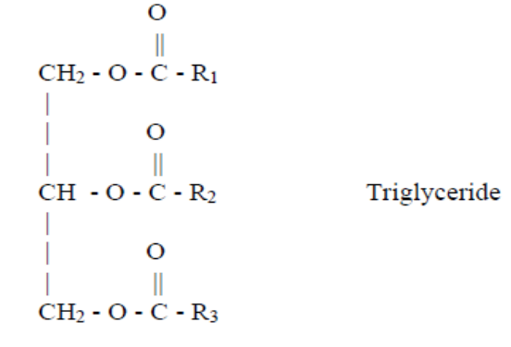
In these molecules, R1, R2, and R3 represent the hydrocarbon chains of the FA groups of the triglyceride. In their free form, FA have the configuration shown below where R is a hydrocarbon chain > 10 carbon atoms¹.

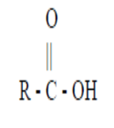
Thus, different FA can be attached to one glycerol backbone. The different FA that is contained in the TAG comprises the FA profile of the bio-oil. Because different FA has different physical and chemical properties, the FA profile is probably the most important parameter influencing the corresponding properties of a bio-oil².
To obtain biodiesel, the bio-oil is subjected to a chemical reaction termed transesterification. In that reaction, the triglyceride is reacted in the presence of a catalyst (usually a base, KOH, NaOH, NaOCH_{3,} etc) with an alcohol (usually methanol) to give the corresponding alkyl esters (or for methanol, the methyl esters) of the FA mixture that is found in the parent bio-oil. The follow figure depicts the transesterification reaction¹.
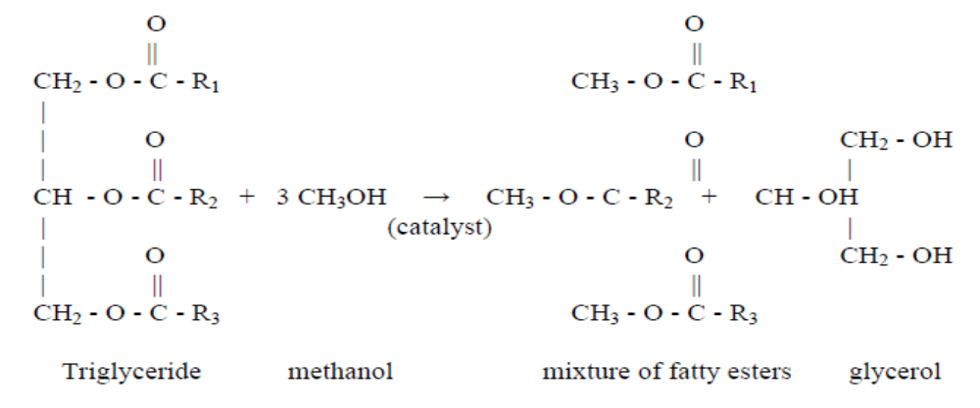
BIODIESEL

The mixture of fatty esters produced by this reaction is referred to as biodiesel. Other terms commonly associated with biodiesel are “soydiesel”, which is biodiesel produced from soybean oil and “methyl soyate” which designates the esters produced from soybean oil and methanol. At the present time, a large portion of the biodiesel sold in the U.S. is produced from the methyl esters of soybean oil, so biodiesel, soydiesel and methyl soyate are often used interchangeably. In general, biodiesel may also include fatty esters derived from other vegetable or animal sources. Other alcohols besides methanol may be used so it will be necessary to distinguish between the three terms¹.
Biodiesel is miscible with petrodiesel in all ratios. In many countries, this has led to the use of blends of biodiesel with petrodiesel instead of neat biodiesel. It is important to note that these blends with petrodiesel are not pure biodiesel. Often blends with petrodiesel are denoted by acronyms such as B20, which indicates a blend of 20% biodiesel with petrodiesel. Of course, the untransesterified triglyceride should also not be called “biodiesel”. Methanol is used as the alcohol for producing biodiesel because is the least expensive alcohol, although other alcohols such as ethanol or iso-propanol may yield a biodiesel fuel with better fuel properties. Often the resulting products are also called fatty acid methyl esters (FAME) instead of biodiesel. Although other alcohols can by definition yield biodiesel, many now existing standards are designed in such a fashion that only methyl esters can be used as biodiesel if the standards are observed correctly².
Biodiesel has several distinct advantages compared with petrodiesel in addition to being fully competitive with petrodiesel in most technical aspects²:
- Derivation from a renewable domestic resource, thus reducing dependence on and preserving petroleum.
- Biodegradability.
- Reduction of most exhausts emissions (with the exception of nitrogen oxides, NO_{x}).
- Higher flash point, leading to safer handling and storage.
- Excellent lubricity, a fact that is steadily gaining importance with the advent of low-sulfur petrodiesel fuels, which have greatly reduced lubricity. Adding biodiesel at low levels (1–2%) restores the lubricity.

For every liter of vegetable oil, the reaction uses 220 milliliters (22% by volume) of methanol, a powerful alcohol. The quantity of Sodium Hydroxide will vary depending upon the quality of our vegetable oil, and will need to be determined by chemical analysis. Students will first calculate the amount of Sodium Hydroxide required for each type of oil (Part 1 of the module). Next, students will test the analyses by making fuel from those oils.

REAGENTS AND MATERIALS
- Safety glasses and chemical resistant gloves
- Ultrasound reactor
- Glass reactor
- Two samples of vegetable oil: used and inused oil
- Sodium Hydroxide, NaOH
- Graduated cylinders: 1000 ml, 100 ml, and 10 ml.
- Pipettes graduated to measure 0.1 ml
- Hot plates with stirring rods
- Beakers of 250 ml
- Thermometer
- Anhydrous Methanol
- Scale accurate to 0.1 grams

SAFETY NOTES: Methanol and NaOH are dangerous substances and should be handled with caution! Methanol is poisonous to skin, and its fumes are highly flammable. NaOH is a strong skin irritant and can cause blindness! Always wear gloves and safety glasses when working with these chemicals, and keep any sparks or flame away from methanol containers. Work under a chemical hood or other well ventilated space.

Other cautions: Biodiesel fuel made in a laboratory is experimental in nature, and should be burned in diesel engines at the users own risk. While well made fuel will not harm a diesel engine, interested students are advised to read further on the subject before actually testing biodiesel in an engine. Do not remove biodiesel fuel from the laboratory classroom.

PROCEDURE³

Part A: Making biofuel from new vegetable oil
1. Everyone must wear safety glasses or goggles and protective gear while handling chemicals.
2. Weight 120 g of new vegetable oil and introduce it into a glass reactor.
3. Heat the vegetable oil to 50°C. One student in your group should watch the temperature closely so the oil does not overheat.
Note: Perform the following 2 steps under a chemical hood.
4. Measure 47.8 ml (amount of alcohol required for 1:6 molar ratio of oil: methanol) of methanol in a graduated cylinder and put into a beaker. Cap the methanol bottle.
5. Weigh 1.8 grams (1.5% kg/L oil) of NaOH and add to the methanol. Gently warm and swirl for a few minutes until all of the NaOH dissolves. You now have sodium methoxide in your beaker, a strong base. Be careful!
6. When the NaOH is dissolved and the oil is up to 50°C, add the methoxide to the warm oil and cap the reactor tightly. Start ultrasonic mixing immediately*. Maintain the constant temperature during the reaction.
*In this step you can choice manual stirring or magnetic stirrer.
Note: You have to ask about procedure for operate the ultrasound reactor.
7. Mix for at least one hour, and then allow your reaction to settle.
8. Over a few minutes, you should see a darker layer (glycerol) forming on the bottom of the reactor, with a lighter layer (biodiesel) floating on top. Complete settling of the reaction will require several hours to overnight. Follow with the next step of the exercise while your biodiesel is settling.
9. Store the reaction vessel until the next session (part 3 of the module) to the analysis of the quality of biodiesel.
10. Clean up your lab space.

Part B. Making biodiesel using waste vegetable oils
In part B, you will use the quantity of NaOH that you determined in part 1 of the module, plus the quantity determined for inused oil, for to make biofuel from used oil. This is basically a repeat of the procedure from part A, except that you will be varying the quantity of NaOH for each batch.

REFERENCE:

J. Van Gerpen. B. Shanks. D. Clements. G. Knote. Biodiesel Analytical Methods. 2002-2004. National Renewable Energy Laboratory NREL

G. Knothe. J. Van Gerpen. J. Krahl. The Biodiesel Handbook. 2005 AOCS Press. Champaign, Illinois.

J. Colucci. E. Borrero. F. Alape. Biodiesel from an Alkaline Transesterification Reaction of Soybean Oil using Ultrasonic Mixing. Journal of the American Oil Chemists’ Society. 2005. 82, 7; Science Module. 525- 530.

